Layer 2 Switch

📶 What is a Layer 2 Switch?
# Source: Chatgpt (GPT‑5 Mini) at [12/18/2025]
A Layer 2 Switch is a network switch that operates at Layer 2 (Data Link Layer) of the OSI model. It forwards data based on MAC addresses and is used to connect devices within the same local area network (LAN).

🔧 Key Functions of a Layer 2 Switch
# Source: Chatgpt (GPT‑5 Mini) at [12/18/2025]
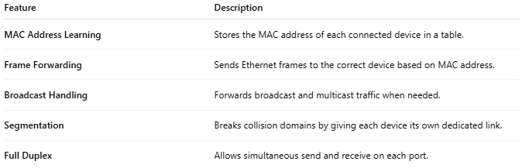

Feature | Description
MAC Address Learning | Stores the MAC address of each connected device in a table.
Frame Forwarding | Sends Ethernet frames to the correct device based on MAC address.
Broadcast Handling | Forwards broadcast and multicast traffic when needed.
Segmentation | Breaks collision domains by giving each device its own dedicated link.
Full Duplex | Allows simultaneous send and receive on each port.

📚 OSI Model Reference
# Source: Chatgpt (GPT‑5 Mini) at [12/18/2025]
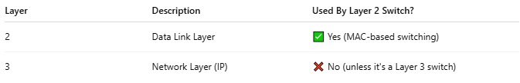

Layer | Description | Used By Layer 2 Switch?
2 | Data Link Layer | ✅ Yes (MAC-based switching)
3 | Network Layer (IP) | ❌ No (unless it's a Layer 3 switch)

🏠 Example Use: Small Office or Campus Network
# Source: Chatgpt (GPT‑5 Mini) at [12/18/2025]
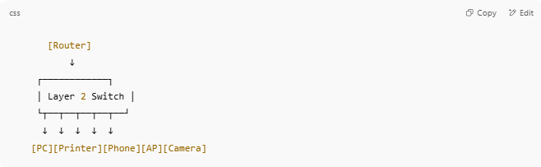

[Router]
↓
┌────────────┐
│ Layer 2 Switch │
└┬──┬──┬──┬──┬──┘
↓ ↓ ↓ ↓ ↓
[PC][Printer][Phone][AP][Camera]

- Devices can communicate internally
- Router is needed for internet or inter-VLAN routing

🆚 Layer 2 vs Layer 3 Switch
# Source: Chatgpt (GPT‑5 Mini) at [12/18/2025]
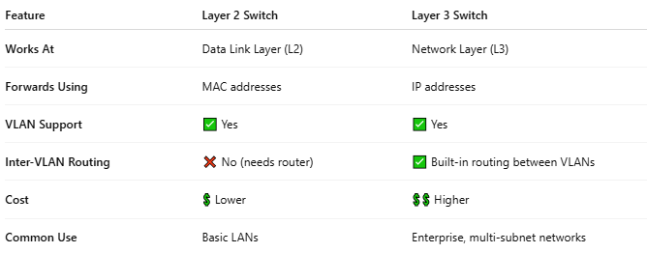

Feature | Layer 2 Switch | Layer 3 Switch
Works At | Data Link Layer (L2) | Network Layer (L3)
Forwards Using | MAC addresses | IP addresses
VLAN Support | ✅ Yes | ✅ Yes
Inter-VLAN Routing | ❌ No (needs router) | ✅ Built-in routing between VLANs
Cost | 💲 Lower | 💲💲 Higher
Common Use | Basic LANs | Enterprise, multi-subnet networks

✅ Benefits of Layer 2 Switches
# Source: Chatgpt (GPT‑5 Mini) at [12/18/2025]
- ✔ Fast switching within the LAN
- ✔ Lower cost and simpler setup
- ✔ Supports VLANs (in most managed models)
- ✔ Ideal for access layer (end-user connections)

❌ Limitations
# Source: Chatgpt (GPT‑5 Mini) at [12/18/2025]
- Cannot route traffic between different subnets or VLANs
- Needs a router or Layer 3 switch for internet access or inter-VLAN communication

